**TAMPILAN UI**

1. Tampilan List Contact

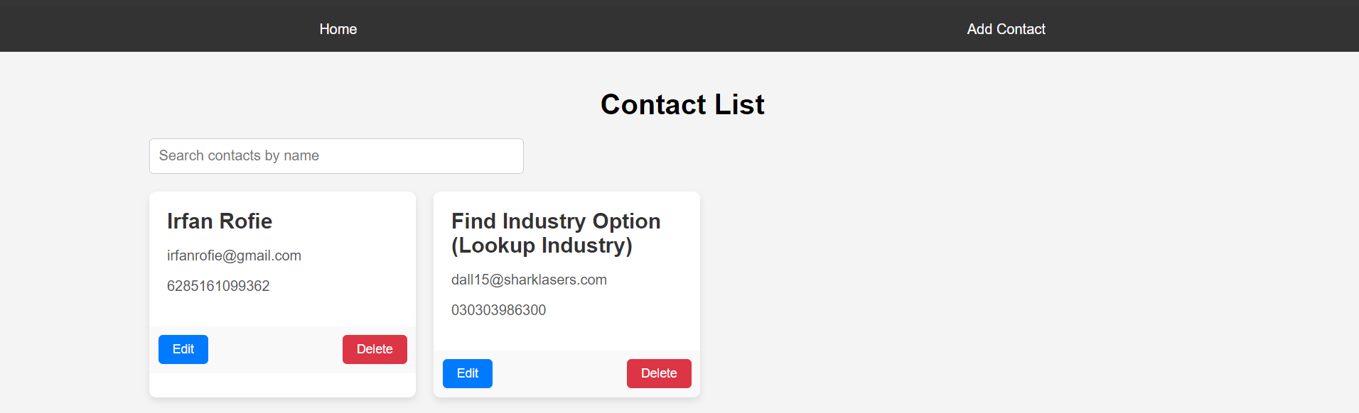

1. Tampilan Search Contact

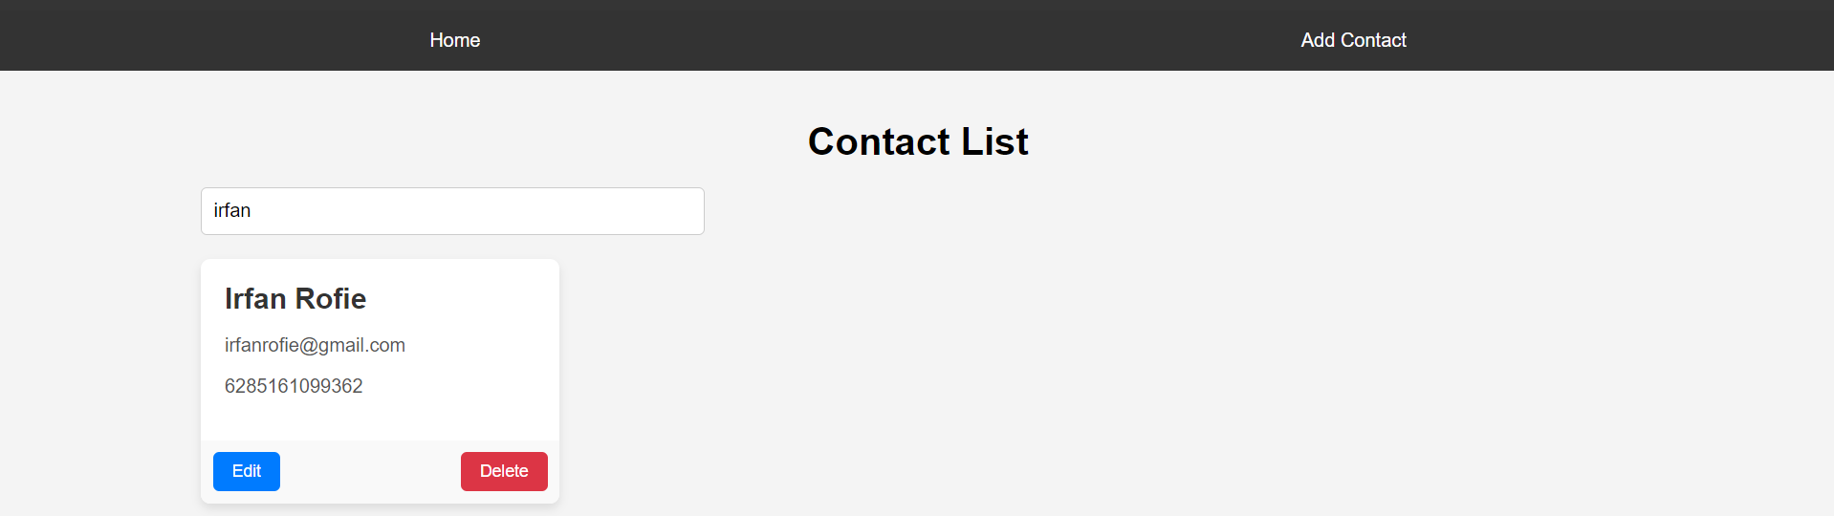

1. Tampilan Add Contact  
   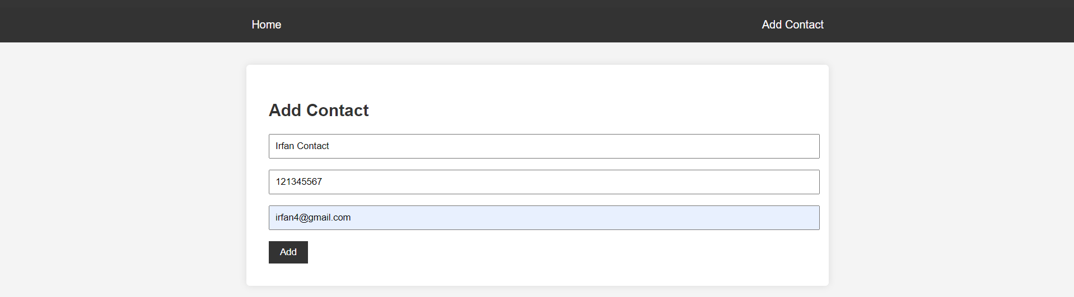

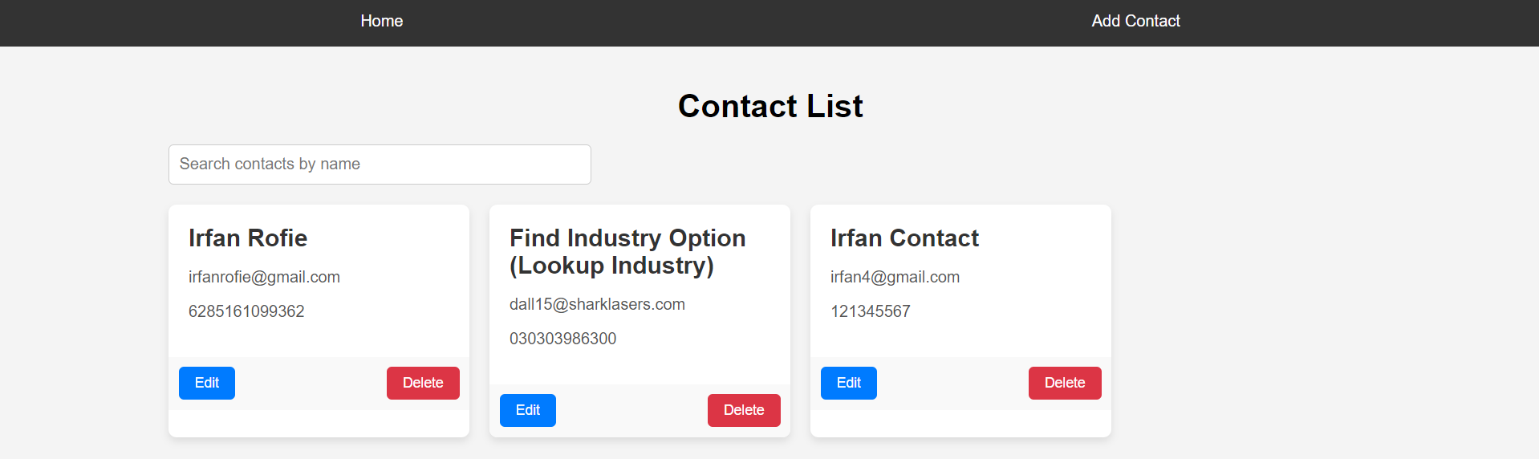

1. Tampilan Edit Contact

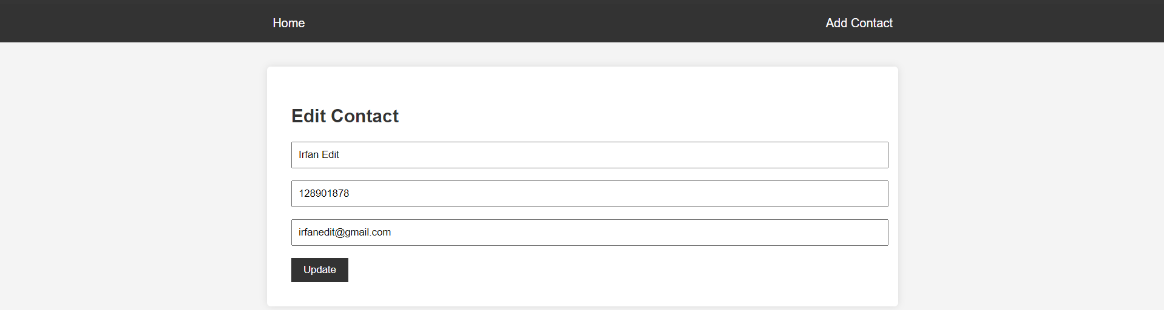

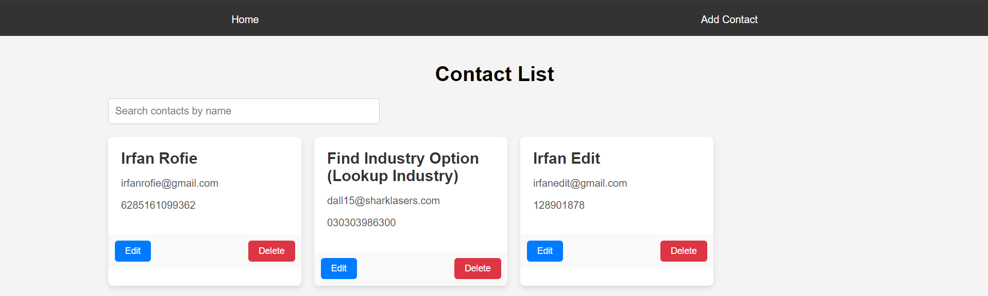

1. Tampilan Delete Contact  
   

